RAMPS V1.4 Tutorial
- Mount the board onto arduono mega 2560, and plug in 5 A4988 driver board, as shown in the picture:
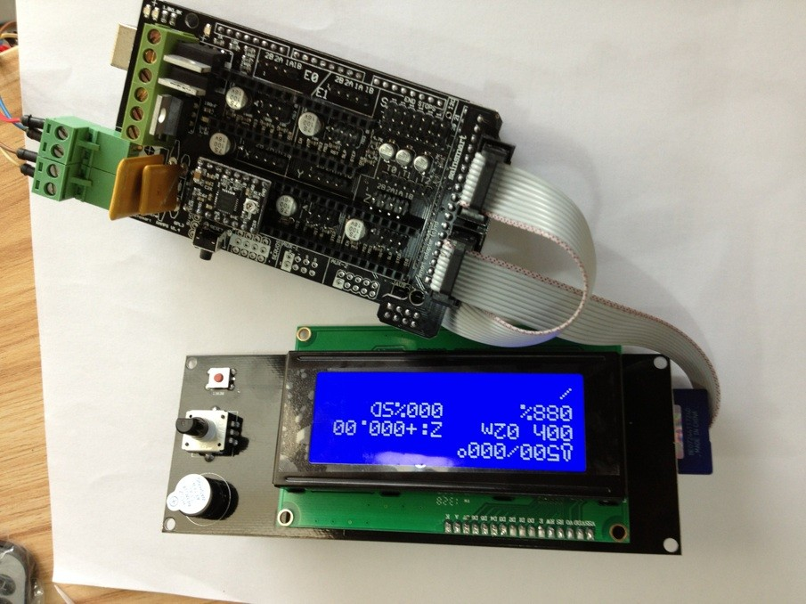

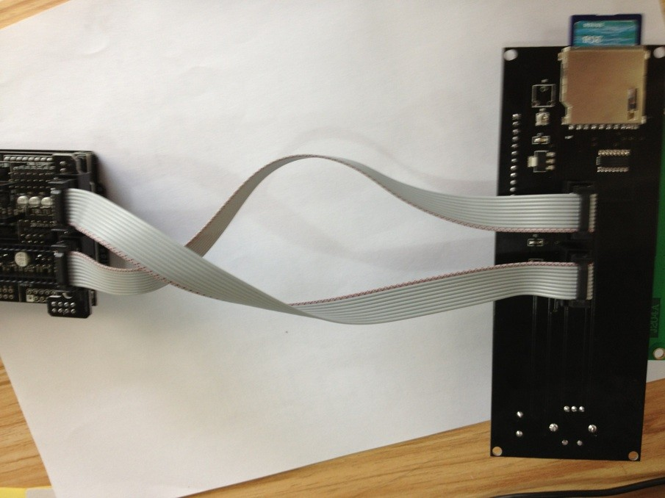
- Add 12V power supply to the green port according to the label on the board
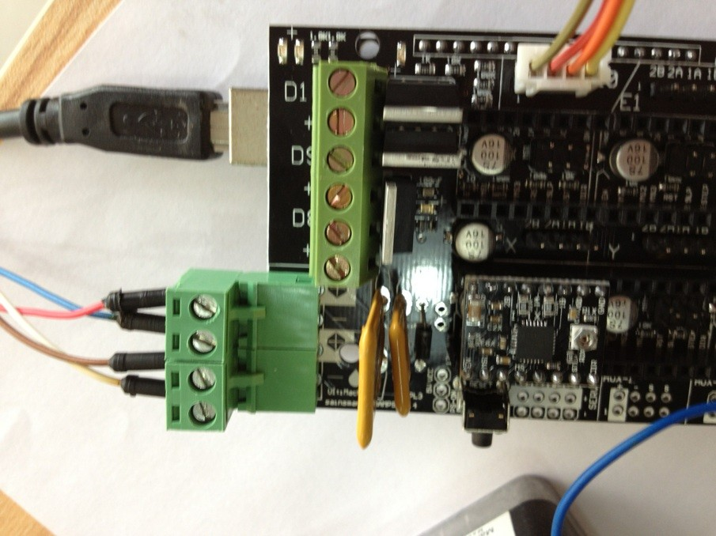

- Wire up 2 Phase and 4 line motor. 1a 1b is 1 phase, 2a 2b is another phase. Connect the board according to the motor pins. Be careful that if it’s wrong wired up, it will damage your motor. See the picture:
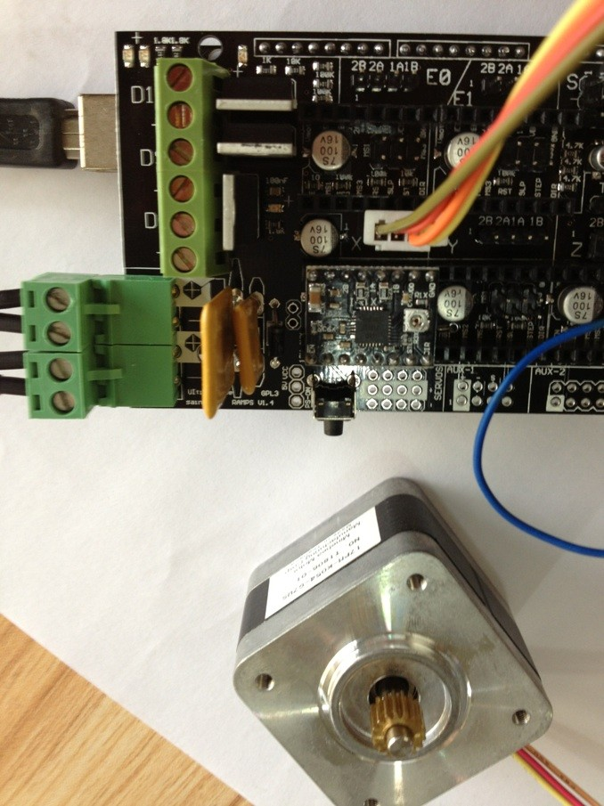

Connect 5 motors to the corresponding port on the board.

- If you want to connect LCD, connect it to the circled area as shown in the picture: 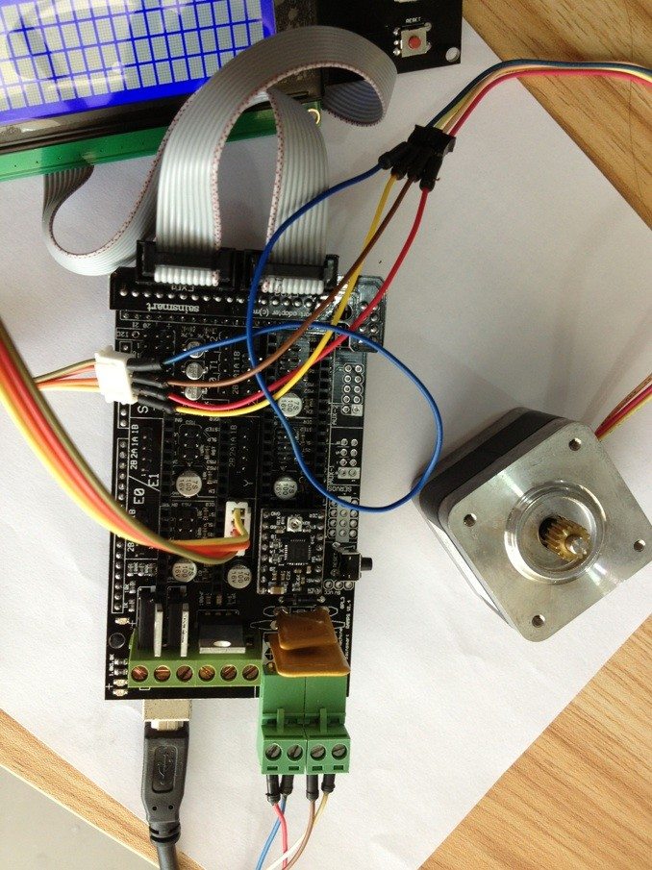

LCD Test
If you have already connected the LCD, you can insert SD card(under 2G) if you want off-line printing.
Use arduino software 0022 to open Marlin. Ino in Marlin folder, upload it to Mega 2560, and every parameter will be shown on LCD. If it’s with SD card, turn the button, select menu to see the document in SD card.

Stepper motor test
If you have already plug in the motor and motor driver correctly, upload the test program to Mega2560, the motor will be working.
#define X_STEP_PIN 54
#define X_DIR_PIN 55
#define X_ENABLE_PIN 38

#define Y_STEP_PIN 60
#define Y_DIR_PIN 61
#define Y_ENABLE_PIN 56

#define Z_STEP_PIN 46
#define Z_DIR_PIN 48
#define Z_ENABLE_PIN 62

#define E0_STEP_PIN 26
#define E0_DIR_PIN 28
#define E0_ENABLE_PIN 24

#define E1_STEP_PIN 36
#define E1_DIR_PIN 34
#define E1_ENABLE_PIN 30

void setup() {
pinMode(X_STEP_PIN, OUTPUT);
pinMode(X_DIR_PIN, OUTPUT);
pinMode(X_ENABLE_PIN, OUTPUT);

pinMode(Y_STEP_PIN, OUTPUT);
pinMode(Y_DIR_PIN, OUTPUT);
pinMode(Y_ENABLE_PIN, OUTPUT);

pinMode(Z_STEP_PIN, OUTPUT);
pinMode(Z_DIR_PIN, OUTPUT);
pinMode(Z_ENABLE_PIN, OUTPUT);

pinMode(E0_STEP_PIN, OUTPUT);
pinMode(E0_DIR_PIN, OUTPUT);
pinMode(E0_ENABLE_PIN, OUTPUT);

pinMode(E1_STEP_PIN, OUTPUT);
pinMode(E1_DIR_PIN, OUTPUT);
pinMode(E1_ENABLE_PIN, OUTPUT);

}

void step(int stepperPin, int steps, int dirPin, boolean dir){
digitalWrite(dirPin,dir);
delay(50);
for(int i=0;i<steps;i++){
digitalWrite(stepperPin, HIGH);
delayMicroseconds(800);
digitalWrite(stepperPin, LOW);
delayMicroseconds(800);
}
}

void loop()
{

digitalWrite(X_ENABLE_PIN, LOW );
digitalWrite(Y_ENABLE_PIN, LOW );
digitalWrite(Z_ENABLE_PIN, LOW );
digitalWrite(E0_ENABLE_PIN, LOW );
digitalWrite(E1_ENABLE_PIN, LOW );

step(X_STEP_PIN, 200, X_DIR_PIN, true);
step(Y_STEP_PIN, 200, Y_DIR_PIN, true);
step(Z_STEP_PIN, 200, Z_DIR_PIN, true);
step(E0_STEP_PIN, 200, E0_DIR_PIN, true);
step(E1_STEP_PIN, 200, E1_DIR_PIN, true);
delay(200);

step(X_STEP_PIN, 200, X_DIR_PIN, false);
step(Y_STEP_PIN, 200, Y_DIR_PIN, false);
step(Z_STEP_PIN, 200, Z_DIR_PIN, false);
step(E0_STEP_PIN, 200, E0_DIR_PIN, false);
step(E1_STEP_PIN, 200, E1_DIR_PIN, false);
delay(200);

}

Micro SD card module test
The module will be connected to the AUX-3pin on the board, when 3D printer is assembled, just put the cad document which you want to print, into SD card.
AUX-3 Pinout:
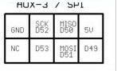

Micro SD card module standalone test
Plug in Micro SD card, connect it to Arduino according to the pins in test program, upload test program and open COMPort Debuger
/*
SD card read/write

This example shows how to read and write data to and from an SD card file
The circuit:
* SD card attached to SPI bus as follows:
** MOSI - pin 11
** MISO - pin 12
** CLK - pin 13
** CS - pin 4

created Nov 2010
by David A. Mellis
modified 9 Apr 2012
by Tom Igoe

This example code is in the public domain.

*/

#include <SD.h>

File myFile;

void setup()
{
// Open serial communications and wait for port to open:
Serial.begin(9600);
while (!Serial) {
; // wait for serial port to connect. Needed for Leonardo only
}

Serial.print("Initializing SD card...");
// On the Ethernet Shield, CS is pin 4. It's set as an output by default.
// Note that even if it's not used as the CS pin, the hardware SS pin
// (10 on most Arduino boards, 53 on the Mega) must be left as an output
// or the SD library functions will not work.
pinMode(10, OUTPUT);

if (!SD.begin(53)) {
Serial.println("initialization failed!");
return;
}
Serial.println("initialization done.");

// open the file. note that only one file can be open at a time,
// so you have to close this one before opening another.
myFile = SD.open("test.txt", FILE_WRITE);

// if the file opened okay, write to it:
if (myFile) {
Serial.print("Writing to test.txt...");
myFile.println("testing 1, 2, 3.");
// close the file:
myFile.close();
Serial.println("done.");
} else {
// if the file didn't open, print an error:
Serial.println("error opening test.txt");
}

// re-open the file for reading:
myFile = SD.open("test.txt");
if (myFile) {
Serial.println("test.txt:");

// read from the file until there's nothing else in it:
while (myFile.available()) {
Serial.write(myFile.read());
}
// close the file:
myFile.close();
} else {
// if the file didn't open, print an error:
Serial.println("error opening test.txt");
}
}

void loop()
{
// nothing happens after setup
}
Other wire up, please refer to the 2000.png

